DAY 1

T1: Protocols
- DNS
- TCP
- TLS
- QUIC
- UDP
- ARP
- ICMP

T2: Packet Analysis
Packet | Protocol | OSI Layer | Reason
Packet 1 | DNS | Layer 7 - Application Layer | DNS is used by applications to convert a domain name such as google.com into an IP address.
Packet 2 | TCP | Layer 4 - Transport Layer | TCP provides reliable communication between two devices and manages the delivery of data.
Packet 3 | TLS | Layer 6 - Presentation Layer | TLS encrypts and protects the data being transferred between the client and server.

T3: OSI Model Diagram
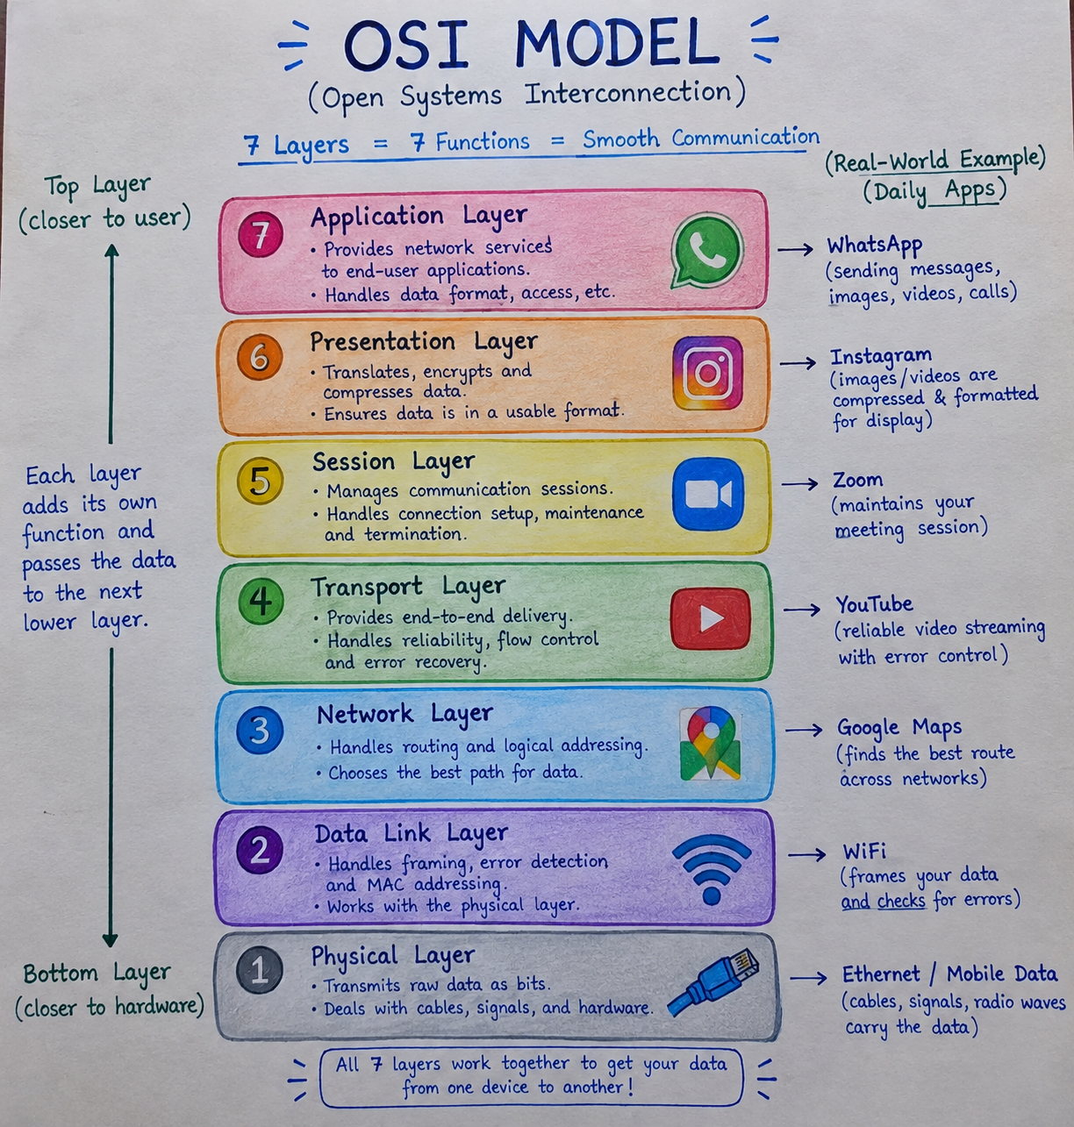

T4: What Happens When I Send "Hey!"
When I type "Hey!" and hit send, a lot happens in a second.

Application layer
This is just the WhatsApp app I'm using. I type my message and choose who to send it to. The app gets the message ready with the text, the person's name and the time.

Presentation layer
Before the message leaves my phone, it gets scrambled (encrypted) so nobody in between can read it. Only my friend's phone has the key to unscramble it. The message is also converted into a format computers can handle easily.

Session layer
My phone opens a connection with WhatsApp's server and keeps it going while we chat. This layer makes sure we stay connected, and if my network drops for a moment, it helps pick things back up.

Transport layer
The message is broken into small pieces and each piece is numbered. That way, if one gets lost on the way, it can be sent again, and everything can be put back in the right order at the end.

Network layer
Each piece gets an address label (IP address) showing where it came from and where it's going. Routers read these labels and pass the pieces along the best route across the internet.

Data link layer
The pieces are passed from one device to the next, like from my phone to my Wi-Fi router. This layer also checks for errors so damaged data doesn't get through.

Physical layer
Finally, everything is turned into actual signals, like radio waves for Wi-Fi or mobile data, or light through fiber cables. This is the real "travelling" part.

On the receiving side
My friend's phone does all of this in reverse. The signals become data, the pieces are put back in order, the message is unscrambled, and WhatsApp shows "Hey!" on their screen.

